Introduction
There is a big gap between sketching a hoodie on an iPad and holding 500 sellable pieces in the warehouse. That gap is called apparel manufacturing, and from the outside it often looks like a black box. Fabrics go in, boxes come out, and nobody is quite sure what happened in between.
From the factory floor, it looks very different. Apparel manufacturing is a clear, step‑by‑step collaboration between you and the manufacturer. When it runs well, your tech pack guides every move, fabric and trims show up on time, samples match your expectations, and bulk production stays on track.
I have spent more than 15 years running production lines for brands of every size. I have seen what breaks orders and what saves them. In this guide, I will walk you through the real production lifecycle, show how to avoid inventory traps, explain the trend gap, and break quality control into a simple three‑point check. By the end, you will know exactly what to expect when you work with a one‑stop partner like Juese Clothing.
“You can’t improve what you don’t understand.” — W. Edwards Deming

Key Takeaways
- Understanding the six core stages of apparel manufacturing gives you a simple map from sketch to shelf. When you know what happens when, you avoid blind spots. That cuts costly mistakes and painful delays, and it makes every conversation with a factory more focused.
- Low minimum order quantities (MOQ) change the risk profile for new brands. Ordering 30 pieces instead of 300 keeps cash free and stock lean. You can test fits, colors, and fabrics with real buyers first, then reorder only what sells.
- Speed and quality now move together when the factory is set up for agile work. A 7–10 day turnaround on simple styles is realistic with the right systems. A clear tech pack and quick approvals keep that clock short, and a one‑stop manufacturer keeps communication and checks in one place.

How Apparel Manufacturing Actually Works – The Production Lifecycle
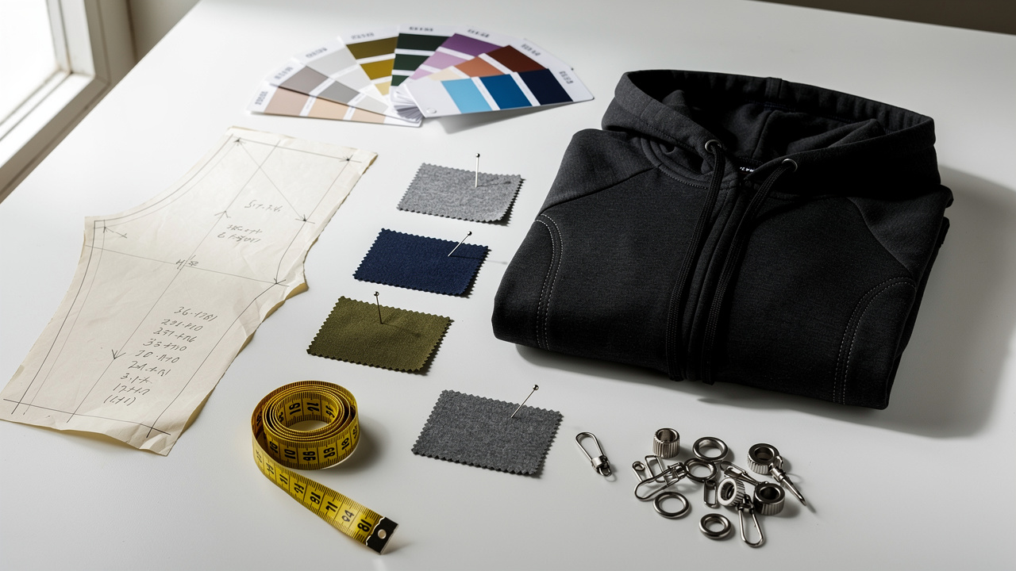
If you strip away the mystery, apparel manufacturing follows a simple path. Think of it in three phases that build on each other: design and development, sampling, and bulk production on the main line.
In the design and development phase, your idea turns into a tech pack. That pack is the recipe for the garment. It lists fabric weight (GSM), stitching details, measurements, color codes, and trim details. When you send a weak pack, you are asking a factory to guess, and guessing on a production floor is expensive.
Next comes sampling. The factory builds one or a few units from your tech pack. This is where you fix fit, adjust fabric choices, and fine‑tune construction. Rushing this stage is the fastest way to create big problems in bulk production.
Once you sign off on the sample, the order moves into bulk production. This is where cutting, sewing, finishing, and packing happen in sequence. A good factory keeps you updated through each part so you do not feel like you handed off control.
To keep it simple, here is the same lifecycle in six short stages:
- Design starts when you move from a sketch to clear technical details. You decide on the fit, the type of fabric, and the overall style. You gather reference pieces so the factory understands your target.
- Sourcing is where fabric and trims are chosen and booked. The factory checks GSM, color, and quality from suppliers. Good sourcing at this point prevents a lot of waste later.
- Cutting begins after the marker and patterns are set. Fabric is spread, then cut into precise panels. Any mistake here multiplies across the whole run.
- Sewing is where panels become real garments. Operators follow a set order of operations so every piece stays consistent. Small in‑line checks keep defects from spreading.
- Finishing covers pressing, trimming loose threads, and adding details. This step also includes decoration such as printing or embroidery when needed. A clean finish is what the buyer notices first.
- Packaging is the final stage before shipment. Garments are folded, bagged, labeled, and boxed to your specs. At this point they should be retail ready, not “almost there.”
When you stay engaged through each phase, apparel manufacturing stops feeling like a gamble and starts feeling like a controlled process.

The Inventory Trap — Why MOQ Is the Biggest Risk for New Brands

Most new brands think fabric or design is their biggest risk. In reality, it is often MOQ, the minimum order quantity. Traditional factories need 300 to 1,000 units per style to justify setting up cutting, sewing, and finishing. That might work for a big retailer. For a first collection, it can sink you.
Here is how that looks on the ground. You hit the factory’s MOQ even though you are not sure what will sell. A few colors or fits move fast. The rest sit in boxes. Cash is tied up, and you cannot react to what the market is telling you.
The smarter path is to treat apparel manufacturing as a series of controlled tests:
- Start with small runs.
- Watch sales in real time.
- Scale only what proves itself.
That is where agile manufacturing comes in.
Modern agile manufacturers like Juese Clothing support MOQs as low as 30 pieces, allowing brands to test the market without heavy stock risk. You can run three colorways at 30 units each instead of one color at 300 units. When a color hits, you reorder fast and let the weak ones fade quietly.
“Inventory is fundamentally evil.” — Tim Cook
That line is blunt, but any founder who has sat on slow‑moving stock knows how true it feels.
This shift is easier to see in a simple comparison.
Factor | Traditional Manufacturing | Agile Manufacturing
Minimum Order Quantity | 300–1,000+ units | As low as 30 units
Turnaround Time | 60–90 days | 7–10 days
Inventory Risk | High | Low
Flexibility | Rigid | Adaptable
Best For | Large established brands | New and growing brands
There is nothing wrong with big factories. They are built for volume. The key is matching your stage with the right style of apparel manufacturing so you are not buried under stock you cannot move.

Speed to Market — Closing the Trend Gap
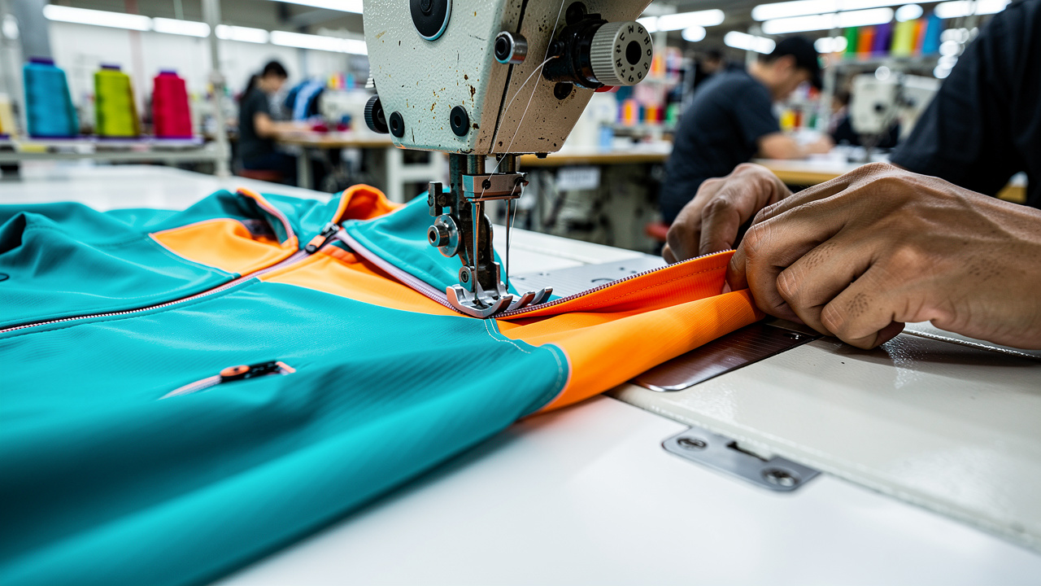
Trends now move faster than most production calendars. If your apparel manufacturing timeline is 45 to 60 days, a micro‑trend you spotted in week one can be gone before your boxes land. That delay is the trend gap—the time between seeing demand and having product in hand.
Closing this gap is not about cutting corners. It is about setting up your line and your partner so the work flows without friction. Pre‑sourced fabric, clear tech packs, and a dedicated production floor make speed possible. Without those, rush orders only create rushed mistakes.
A 7–10 day turnaround is the new gold standard for reactive fashion, enabling brands to restock best‑sellers close to real time. At Juese Clothing, that kind of speed is based on clear inputs, not magic. Simple silhouettes, stable fabrics, and steady communication keep the clock short.
Use that speed where it matters most:
- Plan your core basics and hero styles with a fast‑turn partner.
- Keep heavy, complex, highly detailed pieces on a longer calendar.
- Protect intricate work from being squeezed into a rush window.
Three things slow production more than anything else, and each has a simple fix.
- An incomplete tech pack leaves the sewing line guessing. Missing measurements, unclear GSM, or vague artwork slow every step. Put the work into the pack so questions are answered before the first cut.
- Late fabric approvals push your whole schedule back. When you wait days to confirm a lab dip or quality, the factory cannot move. Block time in your week to review and approve fast.
- Last‑minute design changes hit the line like a brake. Changing prints, trims, or fits after sampling means new work across patterns and markers. Freeze the design once the sample is right and treat later tweaks as a new style.
When you tighten these basics, fast apparel manufacturing becomes a real advantage instead of a nice idea on a mood board.

Quality Control in Plain Language — The 3‑Point Check
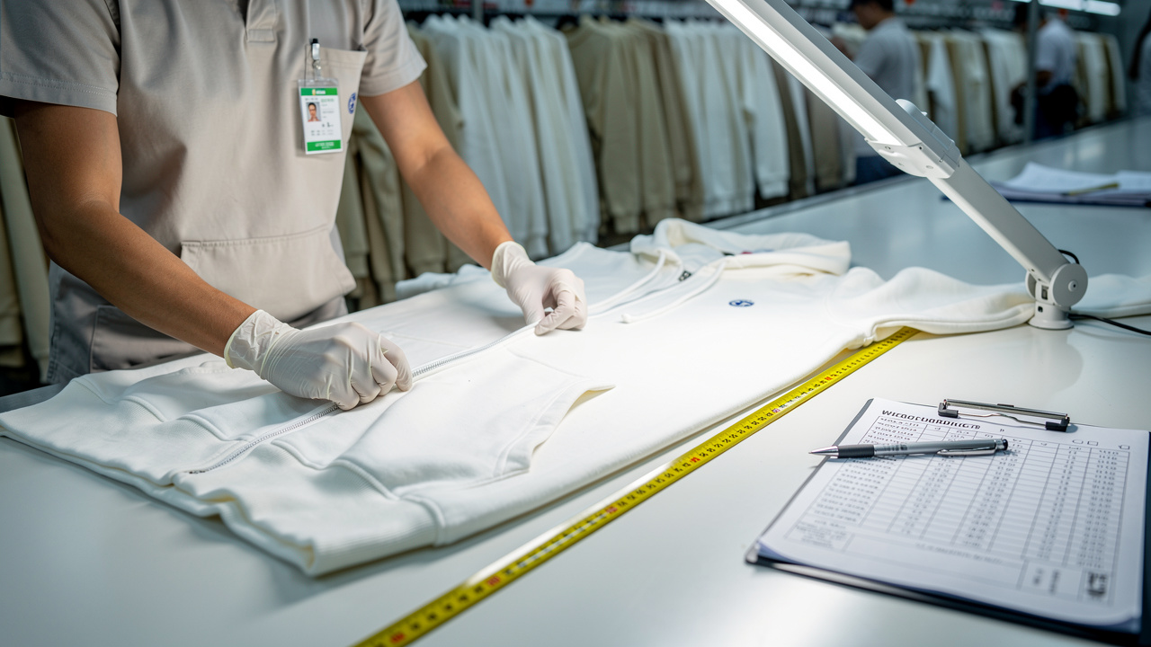
“Quality control” is one of the most used phrases in apparel manufacturing, but almost no one explains what happens. From my side of the table, good control looks like a simple three‑point check that runs through the whole order. Get this right and you protect both your brand and your customer.
“Quality is everyone’s responsibility.” — W. Edwards Deming
The three main checkpoints are:
- Fabric inspection at the start
Rolls are checked for GSM, color consistency, and clear defects such as holes, lines, or dye streaks. When bad fabric is caught here, it can be rejected or cut around with almost no cost. When it slips through, every later step is built on weak material.
- In‑line sewing control while garments are being stitched
Inspectors pull pieces from each station and look at seam strength, stitch count, and alignment against the approved sample. Catching issues in the middle of sewing keeps one operator’s mistake from turning into a full pile of repairs.
- Final iron and pack review
After pressing, garments are laid flat and measured, checked for loose threads, stains, or broken stitches, then matched against your size chart. This is the last chance to pull defects before they end up in a box with your label on it.
Juese Clothing builds this three‑point check into every run, not as a separate step, but as part of the daily routine on the floor. That habit is what keeps repeat orders consistent over time.
Here are some of the problems each checkpoint is designed to catch:
- Fabric inspection picks up color shading, thin spots, and weaving flaws that would show after a few washes. It also finds wrong fiber blends when the fabric does not match the spec. That protects you from early returns.
- In‑line checks spot skipped stitches, twisted seams, and panel mismatch while only a few pieces are affected. The operator can be corrected on the spot. The bulk of the order stays clean.
- Final checks catch size drift, missing trims, and packing errors such as wrong size labels in the neck. This is also where small stains or pressing marks are fixed. Your buyer opens the box and sees a finished garment, not a half‑done project.
When you ask a factory how they run these three checks, you get a fast read on how seriously they treat quality.

Why A One‑Stop Manufacturer Simplifies Everything
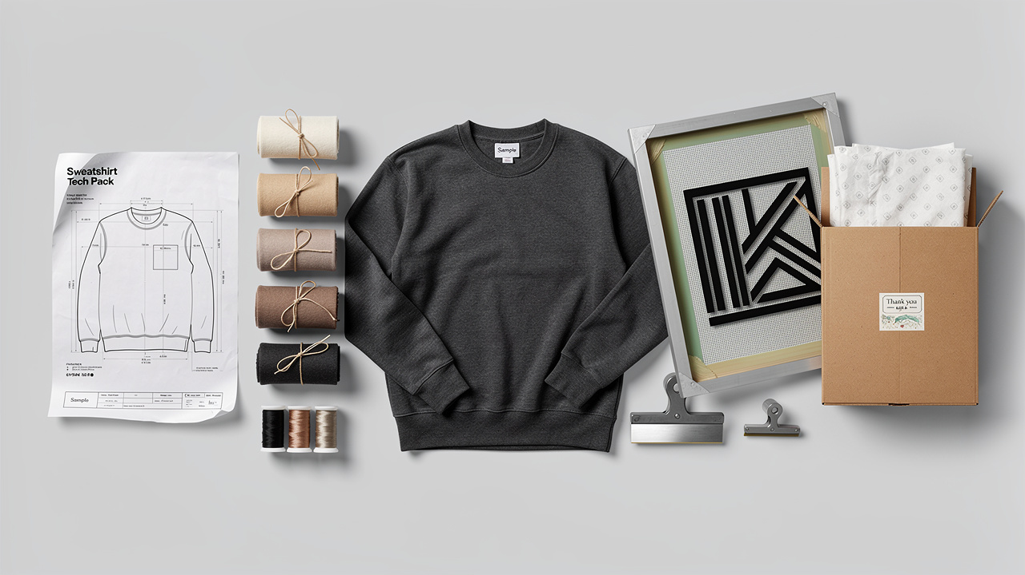
Some brands try to run their own mini supply chain. They buy fabric from one vendor, trims from another, send both to a cut and sew shop, then move finished blanks to a printer, and finally hand the boxes to a freight company. On paper this can look cheap. On the calendar and in real life, it is often a mess.
Each extra handoff is another chance for miscommunication:
- Fabric is late, so the sewing line sits idle.
- Print art is wrong, so boxes of blanks wait in a warehouse.
- When something goes wrong, every vendor blames the next one.
You are stuck in the middle trying to sort it out.
A one‑stop manufacturer takes a different path. One team owns the full chain, from your first idea to the packed carton. You send a tech pack, talk through the design, then work with a single contact as the order moves through sourcing, cutting, sewing, decoration, and shipping.
Juese Clothing runs this kind of integrated model. For you, that looks like a short, clear menu of services handled under one roof:
- Tech pack development and design support help you get the “recipe” right at the start. You do not need a full in‑house technical team. The factory guides you to specs that work on real machines.
- Fabric selection and material sourcing draw on an existing supplier network. You get options that match your price and quality level. The factory checks GSM and hand feel before bulk booking.
- Cut and sew production happens on lines that already know how to handle streetwear, activewear, and everyday basics. That keeps fit consistent from size run to size run.
- Decoration methods such as screen printing, DTG, and embroidery are handled alongside sewing. That cuts transport time between vendors and keeps artwork, placement, and color under one set of eyes.
- Quality control and global logistics are coordinated from the same office that took your first call. You track one timeline, receive one invoice, and speak with one project manager when you have questions.
For a new founder, managing five separate vendors can swallow all the time that should go to design and marketing. A solid one‑stop partner means you can focus on building demand while the factory handles the moving parts of apparel manufacturing.

Conclusion
When you break it down, apparel manufacturing follows a simple path. You lock the design in a clear tech pack, you test it through a proper sample, and you repeat it at scale once everything is dialed in.
The biggest wins come from smart structure, not guesswork. Low 30‑piece MOQs keep inventory risk low, so you can test styles without filling a storage unit. Fast 7–10 day turnarounds on simple pieces help you close the trend gap and restock best‑sellers while buyers still want them. A three‑point fabric, sewing, and final check keeps that speed from eroding quality.
If you are ready to move from sketch to shelf with less stress, a one‑stop partner can make the process far easier. You can start that conversation with a free consultation at jueseclothing.com and see how your next run can be faster, cleaner, and more controlled.

FAQs

What Is A Tech Pack And Do I Need One Before Contacting A Manufacturer?
A tech pack is the recipe for your garment. It lists measurements, fabric weight, construction details, colorways, and trim requirements in one clear file. You do not need a perfect pack on day one, but you do need a solid one before production starts. Juese Clothing can help build or refine your tech pack so it works on the factory floor.

What Is The Minimum Order Quantity For Apparel Manufacturing?
Minimum order quantity (MOQ) is the smallest number of units a factory will produce per style. Big traditional factories often want 300 to 1,000 pieces to make an order worth the setup. Juese Clothing supports MOQs as low as 30 pieces per style, which helps new brands test the market without tying up all their cash in stock.

How Long Does Apparel Manufacturing Take From Sample To Delivery?
Standard timelines in apparel manufacturing run about 45 to 90 days, depending on style complexity, volume, and how many vendors are involved. With an agile partner and simple styles, a 7–10 day production window is realistic once everything is approved. Always add another one to two weeks for sampling and final shipping time when planning your launch.

